Question #7:

#include<iostream>

#include<string>

using namespace std;

int main()

{

string str1 = "WARM";//taking two string //

string str2 = "COLD";

string temp = str1;//swapping these variables//

str1 = str2;

str2 = temp;

cout << str1 << endl;//displaying//

cout << str2 << endl;

system("pause");

return 0;

}

Output:

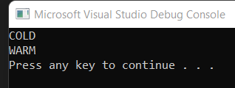

2nd Method :

#include<iostream>

#include<string>

using namespace std;

int main()

{

string str1 = "WARM";//taking two string //

string str2 = "COLD";

str1.swap(str2);

cout << str1 << endl;//displaying//

cout << str2 << endl;

system("pause");

return 0;

}

Output:



Task #8: